**SRI RAMAKRISHNA INSTITUTE OF TECHNOLOGY**

**(An Autonomous Institution)**

**Approved by AICTE, New Delhi– Affiliated to Anna University, Chennai**

**Accredited by NAAC with ‘A’ Grade**

DEPARTMENT OF ELETRICAL AND ELECTRONICS ENGINEERING

**PROJECT BASED LEARNING**

|  |  |
| --- | --- |
| **NAME** | REZWAN B |
| **REGISTER NUMBER** | 71382203018 |
| **YEAR &SEMESTER** | III YEAR & 5th SEMESTER |
| **COURSE CODE** | 20EEP34 |
| **COURSE NAME** | INTRODUCTION TO RASPBERRY PI |
| **PROJECT TITLE** | OBSTACLE AVOIDANCE ROBOT USING RASPBERRY PI PICO |

**TABLE OF CONTENTS :**

|  |  |  |
| --- | --- | --- |
| **SI.NO** | **INDEX** | **PAGE NO** |
|  | ABSTARCT | 3 |
|  | OBJECTIVES | 3 |
|  | INTRODUCTION | 4 |
|  | LIST OF COMPONENTS | 4 |
|  | WORKING OF ULTRASONIC | 5 |
|  | WORKING OF L298N | 7 |
|  | WORKING OF SERVO MOTOR | 9 |
|  | PULSE WIDTH MODULATION | 10 |
|  | PIN DIAGRAM OF RPI2040 | 12 |
|  | BLOCK DIAGRAM | 13 |
|  | ALGORITHM | 13 |
|  | FLOWCHART | 15 |
|  | WOKWI SIMULATION SCREENSHOT | 16 |
|  | WOKWI SIMULATION AND YOUTUBE LINKS | 17 |
|  | PYTHON CODE | 17 |
|  | CONCLUSION & REFERENCE | 23 |

**ABSTRACT**

This project presents the design and implementation of an obstacle-avoiding robot using a Raspberry Pi Pico microcontroller. The robot employs an ultrasonic sensor to detect obstacles in its path and a L298N motor driver to control two gear motors, powered by dual 3.7V Li-ion batteries. The system is programmed to autonomously navigate by avoiding collisions, ensuring smooth movement in dynamic environments. With enhanced response time and adjustable motor speed, the robot demonstrates efficient obstacle detection and avoidance. This project serves as a foundation for developing intelligent mobile systems for applications such as automated delivery and exploration in confined spaces.

**OBJECTIVES:**

The primary objective of this project is to design and develop an autonomous obstacle-avoiding robot that can navigate its environment without human intervention.

The key objectives include:

1. To implement real-time obstacle detection using an ultrasonic sensor.

2. To control the movement of the robot using two gear motors powered by Li-ion batteries and managed by an L298N motor driver.

3. To program the Raspberry Pi Pico microcontroller for efficient decision-making in avoiding obstacles.

4. To improve the robot’s response time to detected obstacles.

5. To allow for adjustable motor speed for optimized movement and performance in different environments.

6. To demonstrate the feasibility of autonomous navigation for potential applications in robotics and automation.

**INTRODUCTION:**

Obstacle-avoiding robots represent an essential step toward developing autonomous systems capable of navigating dynamic environments. This project involves designing and implementing such a robot using the Raspberry Pi Pico microcontroller, an ultrasonic sensor, and an L298N motor driver. The robot uses real-time obstacle detection to adjust its movement, ensuring smooth and collision-free navigation. Powered by dual Li-ion batteries and controlled by efficient programming, the system demonstrates intelligent decision-making and adaptability. This project highlights the practical potential of robotics in automation, with applications ranging from smart navigation to autonomous delivery systems.

**LIST OF COMPONENTS:**

|  |  |  |  |
| --- | --- | --- | --- |
| **S.NO** | **Components** | **Specification** | **Quantity** |
|  | RASPBERRY PI PICO | RPI2040 | 1 |
|  | MOTOR DRIVER | L298n | 1 |
|  | ULTRASONIC SENSOR | HC-SR04 | 1 |
|  | SERVO MOTOR | SG90(180 deg) | 1 |
|  | DC GEARED MOTOR | 100 RPM | 2 |
|  | CONNECTING WIRES | - | As Required |
|  | LI-ION BATTERIES | 3.7V,2500mAh | 2 |

**WORKING OF ULTRASONIC SENSOR:**

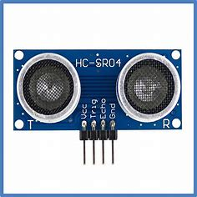

Figure

1**. Pins:**

**-VCC**: Connects to 5V power supply.

-**GND**: Connects to ground.

-**Trig**: Sends ultrasonic pulse when triggered by the microcontroller.

-**Echo**: Outputs a signal for the time of flight of the echo.

2.**Working**:

-**Trigger Pulse**: A 10µs HIGH signal on Trig pin emits ultrasonic waves.

-**Echo Signal**: Echo pin goes HIGH when reflected waves are received.

-**Time Measurement**: Microcontroller measures how long Echo pin stays HIGH.

-**Distance Calculation**:

This process provides real-time distance data for obstacle detection.

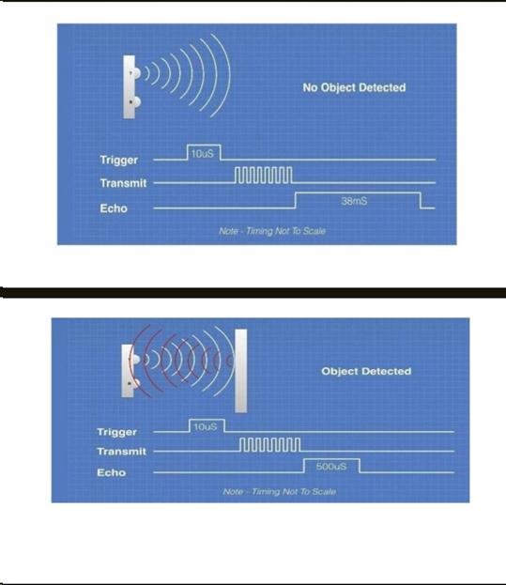

**Distance= (Time x Speed of Sound in Air (343 m/s))/2.**

Figure

**WORKING OF L298N:**

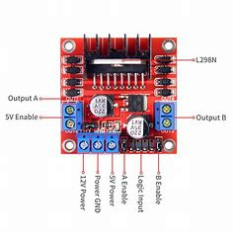

Figure

1. **Pins**:
   * **Power Pins**:
     + **VCC**: Connects to motor power supply (up to 12V).
     + **GND**: Common ground for power and control.
     + **5V**: Provides 5V output (used for logic circuits if needed).
   * **Control Pins**:
     + **IN1, IN2, IN3, IN4**: Control motor directions (two pins per motor).
   * **Enable Pins**:
     + **ENA, ENB**: Control motor speed using PWM signals.
   * **Output Pins**:
     + **OUT1, OUT2, OUT3, OUT4**: Connect to motor terminals.
2. **Working**:
   * **Direction Control**: Input pins (e.g., IN1 and IN2) are toggled HIGH/LOW to set motor rotation direction.
   * **Speed Control**: PWM signals applied to ENA (Motor A) or ENB (Motor B) pins adjust speed.
   * **Motor Output**: Voltage is supplied to the motors via OUT1-OUT4 based on control signals.
   * The L298N motor driver is based on the H-bridge configuration (an H-bridge is a simple circuit that lets us control a DC motor to go backward or forward.), which is useful in controlling the direction of rotation of a DC motor.

**H-BRIDGE CIRCUIT DIAGRAM**

Figure

**Change in the direction of rotation of the motor using h-bridge**

Figure

When S1 and S4 are ON and S2 and S3 are OFF, the left side of the motor terminal is more +ve than the other terminal. This causes the clockwise rotation of the motor.

When S2, S3 are ON and S1, S4 are OFF, the right side of the motor terminal is more +ve than the left terminal. This causes anticlockwise rotation of the motor.

**WORKING OF SERVO MOTOR:**

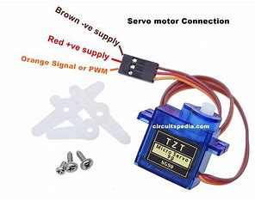

Figure

1. **Pins**:
   * **VCC**: Connects to a 5V power supply.
   * **GND**: Connects to the ground of the circuit.
   * **Signal**: Receives PWM signal from the microcontroller to control the angle.
2. **Working**:
   * **PWM Signal**: The microcontroller sends a PWM signal to the signal pin, where the pulse width determines the servo's position.
     + A pulse width of ~1 ms rotates the servo to 0°.
     + ~1.5 ms sets it to 90° (middle position).
     + ~2 ms rotates it to 180°.
   * **Internal Mechanism**: The servo's internal control circuit adjusts the motor to match the position specified by the PWM signal.
   * **Continuous Adjustment**: The servo continuously monitors and maintains its position until the PWM signal changes.

This allows precise angular control, making servos ideal for tasks like steering or positioning.

**PULSE WITH MODULATION:**

PWM is a technique used to control the amount of power delivered to a device by varying the width of a digital signal's "ON" time (pulse width) while keeping the signal's frequency constant. It is widely used for motor control, LED dimming, and other applications requiring variable power.

1. **Duty Cycle**:

**The form of calculating the duty cycle**

Example: 50% duty cycle means the signal is ON half the time.

1. **Frequency**:
   * How often the PWM signal repeats in one second, measured in Hertz (Hz).

**PWM Graph Description:**

1. **X-Axis**: Time
2. **Y-Axis**: Voltage (HIGH/LOW states)
3. **Waveforms**:
   * **Low Duty Cycle**: Narrow HIGH pulses (low average power).
   * **Medium Duty Cycle**: Wider HIGH pulses (moderate power).
   * **High Duty Cycle**: Very wide HIGH pulses (high power).

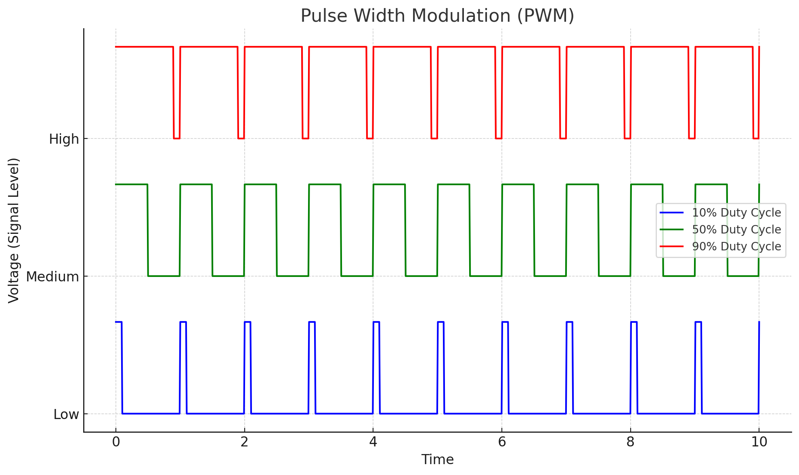

Table

Figure

The graph above illustrates PWM signals with varying duty cycles:

1. **10% Duty Cycle**: The signal is HIGH for only 10% of the time, delivering low power.
2. **50% Duty Cycle**: The signal is HIGH for half the time, delivering moderate power.
3. **90% Duty Cycle**: The signal is HIGH for most of the time, delivering high power.

**PIN DIAGRAM OF RPI2040:**

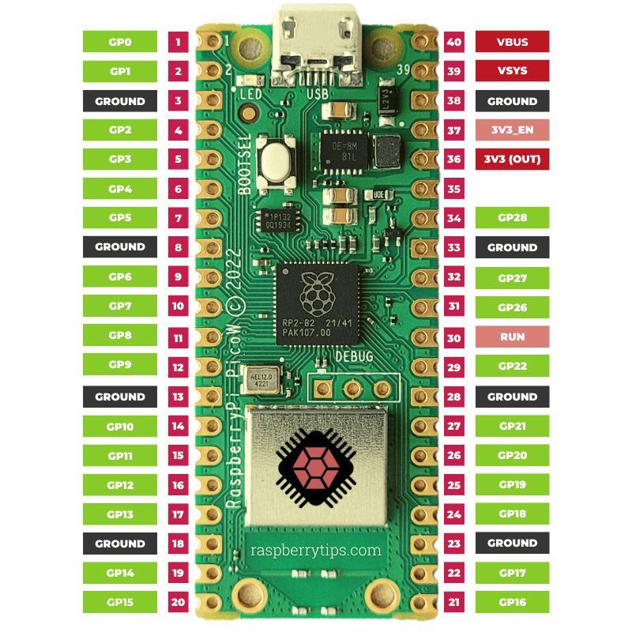

Figure

**BLOCK DIAGRAM:**

**ALGORITHM:**

**Step 1**: **Initialization**

1. Initialize the ultrasonic sensor, servo motor, and motor driver.
2. Set the servo motor to the forward-facing position (90°).
3. Start the robot's motors for forward movement.

**Step 2**: **Obstacle Detection**

1. Continuously read the distance from the ultrasonic sensor.
2. If the distance is greater than the threshold (e.g., 20 cm), continue forward.
3. If the distance is less than the threshold:
   * Stop the motors.

**Step 3**: **Reverse**

1. Reverse the robot for a predefined time (e.g., 1 second) to move away from the obstacle.

**Step 4**: **Scan for Clear Path**

1. Rotate the servo to the left (e.g., 45°) and measure the distance using the ultrasonic sensor.
2. Rotate the servo to the right (e.g., 135°) and measure the distance again.

**Step 5**: **Decision Making**

1. Compare the left and right distances:
   * If the left distance is greater, turn the robot left and move forward.
   * If the right distance is greater, turn the robot right and move forward.
   * If both are similar, move forward in the original direction.

**Step 6**: **Repeat**

1. Reset the servo to the forward position (90°).
2. Continue obstacle detection and follow the same logic.

**FLOW CHART:**

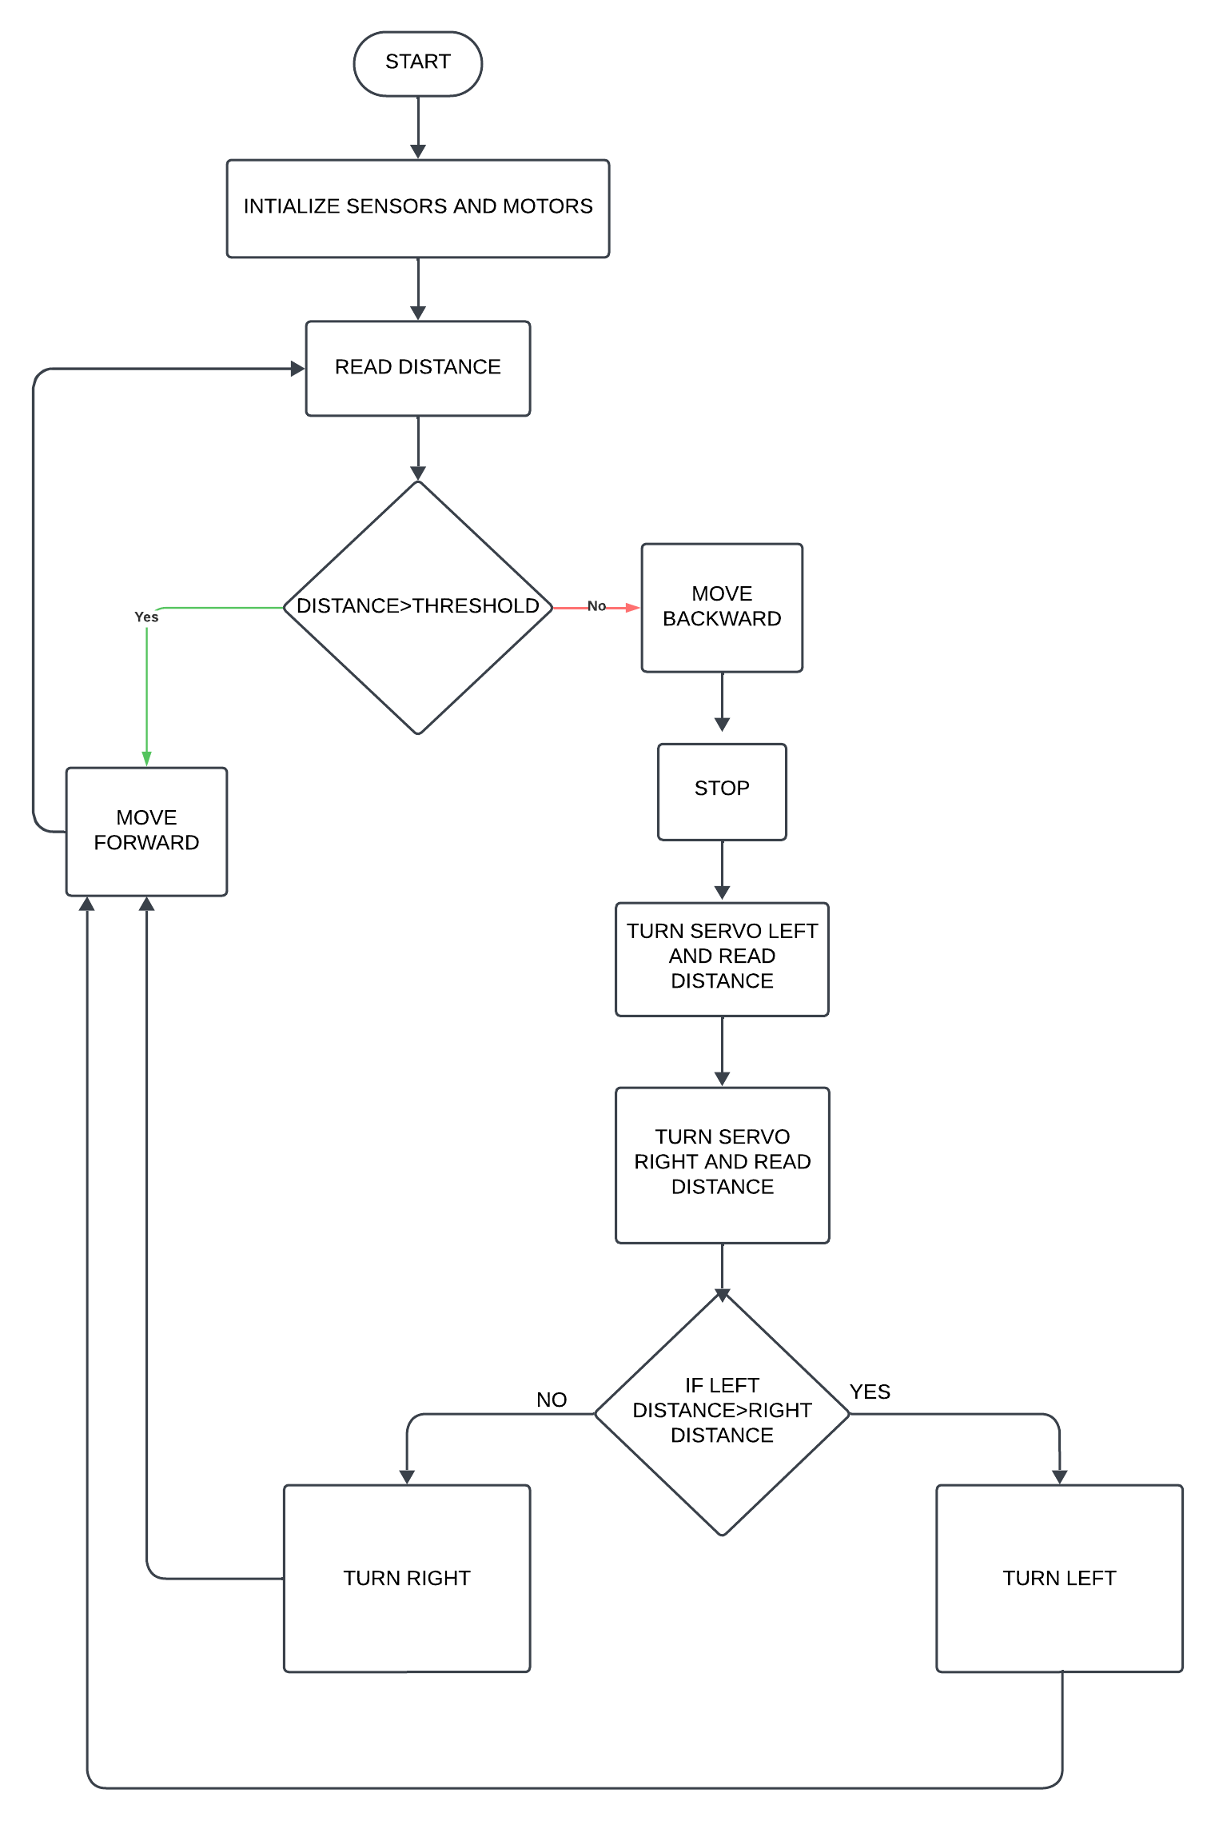

**WokWI SIMULATION SCREENSHOT:**

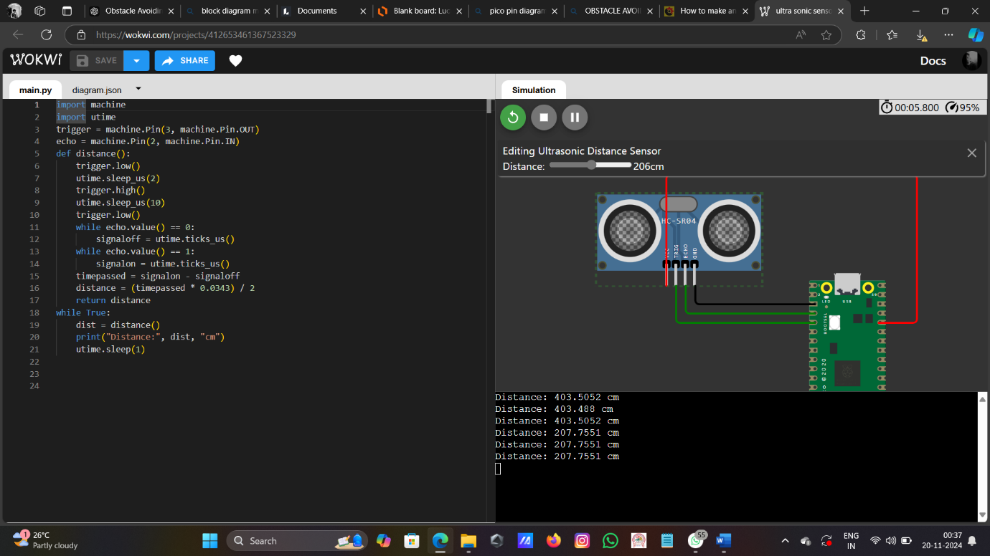

Figure

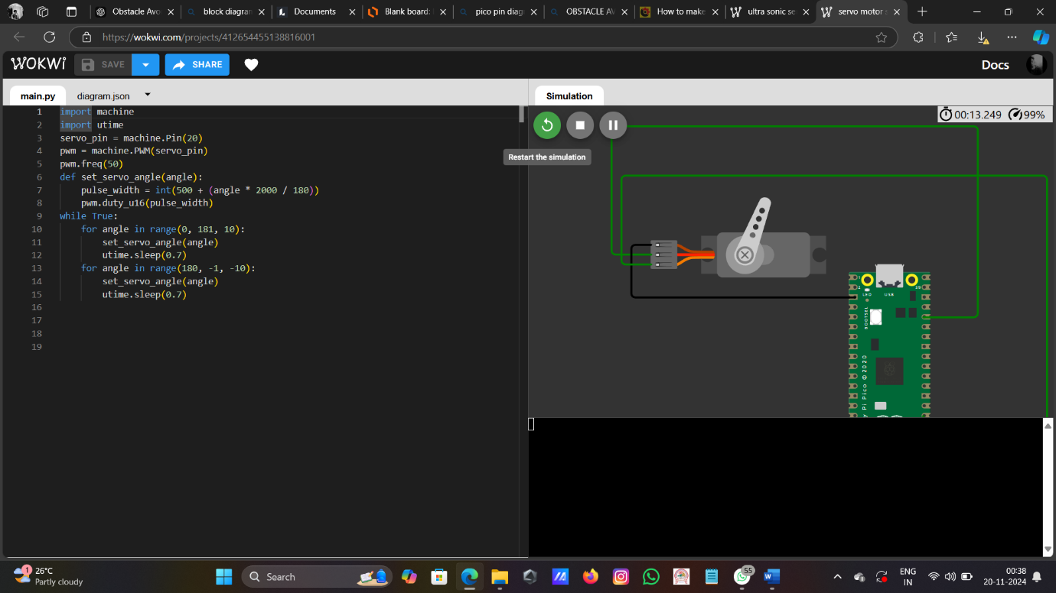

Figure

**SIMULATION LINK:**

**SERVO:**<https://wokwi.com/projects/412654455138816001>

**ULTRASONIC:**<https://wokwi.com/projects/412653461367523329>

**YOUTUBE LINK:**

https://youtu.be/5-6wZcI21LE?si=d-51qDfIVQQc-pcn

**PYTHON CODE:**

from machine import Pin, PWM

import time

# Initialize the servo motor

servo = PWM(Pin(16)) # Servo pin set to 12

servo.freq(50)

# Initialize the ultrasonic sensor pins

Trig = Pin(18, Pin.OUT) # Trig pin set to 10

Echo = Pin(19, Pin.IN) # Echo pin set to 11

# Motor driver pins (L298N connections)

ENA = PWM(Pin(14)) # Enable pin A set to 6

IN1 = Pin(9, Pin.OUT) # Input pin 1 set to 2

IN2 = Pin(8, Pin.OUT) # Input pin 2 set to 3

IN3 = Pin(7, Pin.OUT) # Input pin 3 set to 4

IN4 = Pin(6, Pin.OUT) # Input pin 4 set to 5

ENB = PWM(Pin(15)) # Enable pin B set to 7

ENA.freq(1000)

ENB.freq(1000)

# Adjusted speed for lower power consumption and better response

speed = 30000 # Speed of the robot (lower for safer operation)

def forward():

ENA.duty_u16(speed)

IN1.value(0)

IN2.value(1)

ENB.duty_u16(speed)

IN3.value(1)

IN4.value(0)

print("Moving Forward")

def backward():

ENA.duty_u16(speed)

IN1.value(1)

IN2.value(0)

ENB.duty_u16(speed)

IN3.value(0)

IN4.value(1)

print("Moving Backward")

def left():

ENA.duty_u16(speed)

IN1.value(1)

IN2.value(0)

ENB.duty_u16(speed)

IN3.value(1)

IN4.value(0)

print("Turning Left")

def right():

ENA.duty_u16(speed)

IN1.value(0)

IN2.value(1)

ENB.duty_u16(speed)

IN3.value(0)

IN4.value(1)

print("Turning Right")

def stop():

ENA.duty_u16(0)

IN1.value(0)

IN2.value(0)

ENB.duty_u16(0)

IN3.value(0)

IN4.value(0)

print("Stopped")

# Function to get the distance from the ultrasonic sensor

def distance():

Trig.value(0)

time.sleep_us(2)

Trig.value(1)

time.sleep_us(10)

Trig.value(0)

while Echo.value() == 0:

low = time.ticks_us()

while Echo.value() == 1:

high = time.ticks_us()

t = high - low

cm = t / 29 / 2 # Convert time to cm

print(f"Measured distance: {cm:.2f} cm")

return cm

def servo_left():

servo.duty_u16(7500) # Move servo to the left

print("Servo moved left")

def servo_right():

servo.duty_u16(1800) # Move servo to the right

print("Servo moved right")

def servo_start():

servo.duty_u16(4800) # Center the servo

print("Servo centered")

while True:

dis = distance()

if dis < 15: # Obstacle detected within 15 cm

stop()

time.sleep(0.2)

# Backward for a short time before turning

backward()

time.sleep(0.5) # Reverse for half a second

stop()

time.sleep(0.2)

# Scan to the left

servo_left()

time.sleep(0.2) # Wait for the servo to move

left_dis = distance() # Measure left distance

print("Left Distance:", left_dis)

# Center the servo

servo_start()

time.sleep(0.2) # Centering time

# Scan to the right

servo_right()

time.sleep(0.2) # Wait for the servo to move

right_dis = distance() # Measure right distance

print("Right Distance:", right_dis)

# Center the servo back

servo_start()

time.sleep(0.2) # Centering time

# Decision making based on distance readings

if left_dis > right_dis:

print("Decision: Turn Left")

left() # Turn left

time.sleep(0.5)

else:

print("Decision: Turn Right")

right() # Turn right

time.sleep(0.5)

stop() # Stop after turning

time.sleep(0.5) # Wait before moving again

else:

forward() # No obstacles, move forward

time.sleep(0.1) # Short delay for forward movement

**CONCLUSION:**

The obstacle-avoiding robot successfully demonstrates the integration of sensors, actuators, and control algorithms to achieve autonomous navigation. By utilizing an ultrasonic sensor for real-time obstacle detection, a servo motor for directional scanning, and an L298N motor driver for movement control, the robot efficiently identifies and avoids obstacles. The implemented algorithm ensures smooth operation, allowing the robot to reverse and select the optimal path when faced with obstacles. This project highlights the potential of robotics in automation and sets a foundation for further enhancements, such as improved obstacle detection range, advanced path planning, and multi-sensor integration for complex environments.

**REFERENCES:**

**Ultrasonic senser** : [HC-SR04 (sparkfun.com)](https://cdn.sparkfun.com/datasheets/Sensors/Proximity/HCSR04.pdf)

**Servo Motor** :[SERVO MOTOR SG90 DATA SHEET (ic.ac.uk)](http://www.ee.ic.ac.uk/pcheung/teaching/DE1_EE/stores/sg90_datasheet.pdf)

**Motor Driver:** [L298N Motor Driver.pdf (handsontec.com)](https://www.handsontec.com/dataspecs/module/L298N%20Motor%20Driver.pdf)

**Raspberry Pi Pico:** [Raspberry Pi Pico Datasheet (components101.com)](https://components101.com/sites/default/files/2021-01/Raspberry-Pi-Pico-Microcontroller-Datasheet.pdf)

**Dc Moter**:[Microsoft Word - Document5 (digikey.com)](https://media.digikey.com/pdf/Data%20Sheets/Adafruit%20PDFs/3777_Web.pdf)